3.2 Functions of Two or More Variables Worksheet

- Let . Determine the limits in the problem below. Make sure you write a full argument to justify your position.

- Determine .

We calculate .

- Determine .

If we progress towards along we see that
.
However, if we progress towards along (as we did in part (a)) we see that
Since this limit has different answers as we progress towards along different paths, we can say that DNE.

- Determine

We clearly see that at is continuous and therefore we calculate

- Determine whether each of the following limits exists. Make sure you write a full argument to justify your position.
- .
If we progress towards along we see that
.
However, if we progress towards along we see that
Since this limit has different answers as we progress towards along different paths, we can say that DNE.

This limit is difficult to evaluate at first. So, if we let then as clearly . Therefore,

If we progress towards along we see that
.
However, if we progress towards along we see that
Since this limit has different answers as we progress towards along different paths, we can say that DNE.

If we progress towards along we see that
.
However, if we progress towards along we see that
Since this limit does not exist along the path we can say that DNE.

If we progress towards along we see that
.
However, if we progress towards along we see that
Since this limit has different answers as we progress towards along different paths, we can say that DNE.

Since is continuous at we easily compute that

- .

Note that

- Consider the following piecewise functions and determine .

We see that along the path ,

We see that along the path ,

Clearly and so DNE.

- Hint: Consider the path at some point.

We see that along the path ,

We see that along the path ,

Clearly and so DNE.

We see that along the path ,

We see that along the path ,

Clearly and so DNE.

We see that along the path ,

We see that along the path ,

Clearly and so DNE.

We see that along the path ,

We see that along the path ,

Clearly and so DNE.

- Let F be a function of x and y. Consider the following statements.
- as along every straight line through , but does not exist.
- as along the lines and , but does not exist.
- as along the lines and , but .

Which statements could possibly be true?

A could be true as long as does not exist along some other curve.
B could be true as long as does not exist along some other curve.
C cannot be true since along some paths and so it cannot be true that .

Therefore, only A & B could possibly be true.

- Mark exactly one box corresponding to the correct ending of the sentence.
“The limit …
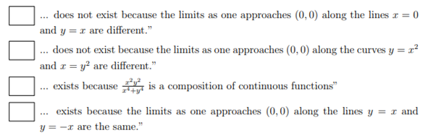

The 2nd statement is false since along both of the given paths .
The 3rd statement is false since the function is discontinuous at and at least one function used in a composition to create this would also be discontinuous at .
The 4th statement is false since we have not determined that the limit is always produces the same result along all paths approaching .

- Let f be a function from to . Suppose that as along every line of the form . What can you say about the limit ? Select all that apply.
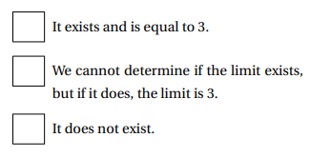
We cannot determine the limit at this time since we do not know what happens as along all possible paths.

- Determine 5 different paths along which you can compute the limit .

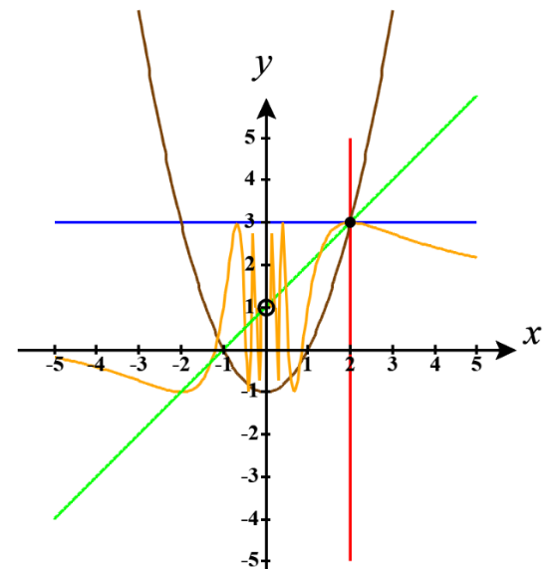
Since our limit has approaching we need paths that lead us to the point .
Here are 5 different possible paths:
Path 1:
Path 2:
Path 3:
Path 4:
Path 5:

- Calculate the following limit.

If we let , then we see that as it is the case that .
Therefore, we can say that
Now since we have reduced the limit to a limit in one variable we see that using L’Hopital’s Rule is valid. However, the current form of the limit will cause the use of L’Hopital’s Rule to loop indefinitely and therefore we will first rewrite the limit and then calculate the result.
Therefore, .
- Is the function continuous at ?

We see that and . Therefore, and thus f is not continuous at .

Along we get
Note that this implies that either or DNE.
However, and so there is no way that . Therefore, cannot be continuous at , but will be continuous everywhere else.

Along we get .
Along we get
Note that this implies that either DNE.
Therefore, cannot be continuous at , but will be continuous everywhere else.

